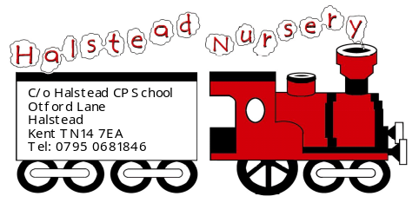
8.2 Maintaining children’s safety and security on premises
Policy statement

We maintain the highest possible security of our premises to ensure that each child is safely cared for during their time with us.

Procedures

Children's personal safety
- We ensure all employed staff have been checked for criminal records by an enhanced disclosure from the Criminal Records Bureau.
- Adults do not normally supervise children on their own.
- All children are supervised by adults at all times.
- Whenever children are on the premises at least two adults are present.
- We carry out risk assessment to ensure children are not made vulnerable within any part of our premises, nor by any activity.

Security
- Systems are in place for the safe arrival and departure of children.
- The times of the children's arrivals and departures are recorded.
- The arrival and departure times of adults - staff, volunteers and visitors - are recorded.
- Our systems prevent unauthorised access to our premises.
- Our systems prevent children from leaving our premises unnoticed.
- The personal possessions of staff and volunteers are securely stored during sessions.
This policy was adopted at a meeting of | Halstead Nursery | name of provider
Held on | September 3rd 2014 | (date)
Date to be reviewed | September 2015 | (date)
Signed on behalf of the management committee
Name of signatory | Patricia Dunmall
Role of signatory (e.g. chair/owner) | Chair
Other useful Pre-school Learning Alliance publications

- Managing Risk (2009)

